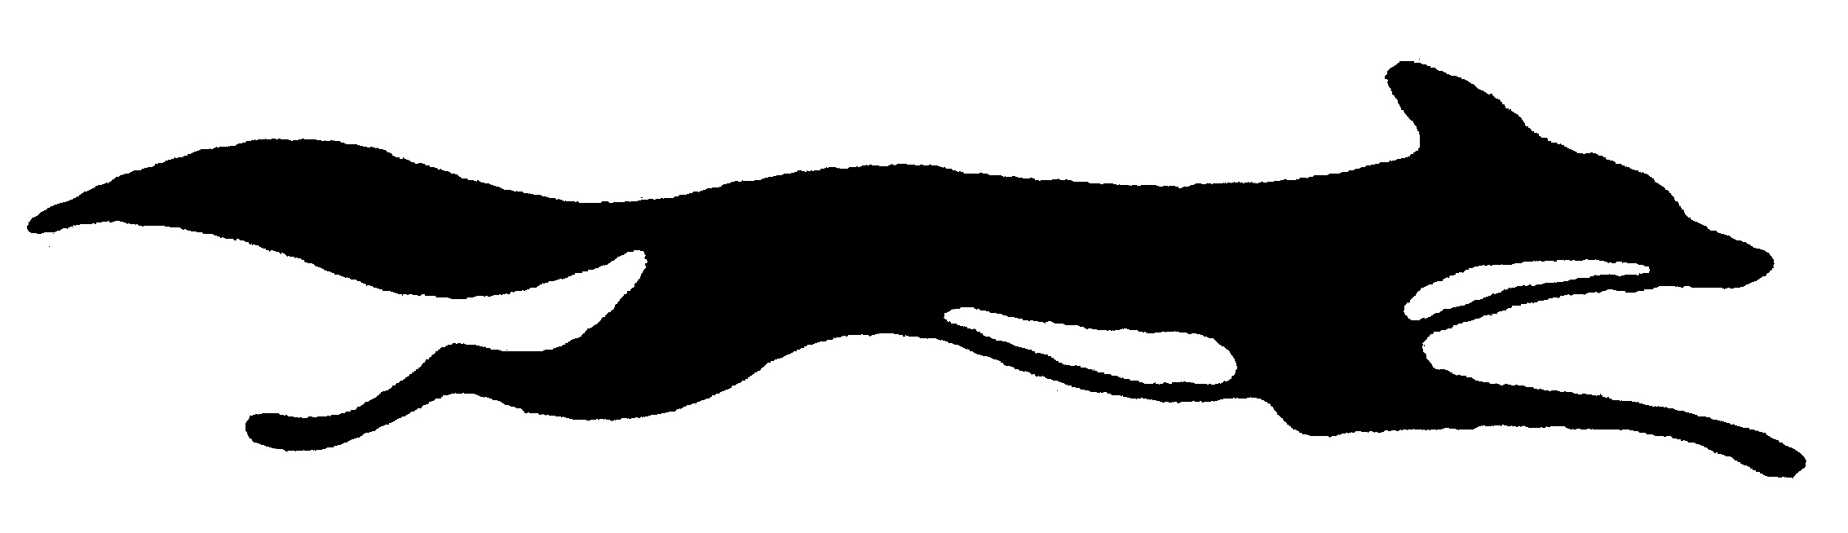
FOX ENGINEERING L.L.C.
FILTRATION & PUMPS
PUMPS ● SEALS ● FILTRATION HOUSINGS ● CLEANING SYSTEMS
“ZERO DEFECTS”

We supply a full range of services from engineering consultation to complete system design; our pump replacement parts are equal to, or better than, your original equipment and our prices are definitely better. We are happy to quote pump parts, power ends, rotating assemblies, and complete pumps for immediate sale and shipment.

Major Manufacturers Represented:

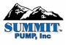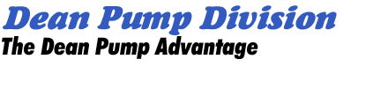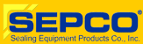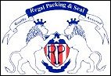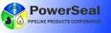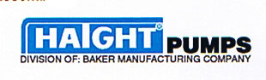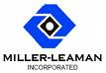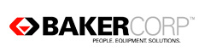

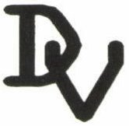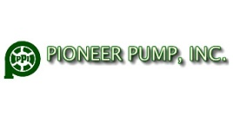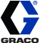
Fox Filtration Housings/Seals – Solvent Reclaimers – Cat Pump Cleaning Systems Aftermarket Parts for Other Pumps: Flowserve, Goulds, Durco, Worthington, Ahlstrom, Warren, Bingham, Sulzer, Ingersoll-Rand, Worman Replacement Parts. Davis Valves, All Major Valve Lines Available
Key Products:

Systems
Pumps
Accessories

Heat Exchangers Solvent Transfer Pumps Filtration-Steel/Mesh/Cloth/Synthetic Paper
Mix Tanks-Stainless Air Diaphragm Pumps Sanitary Fittings/Ferrules
Custom Tanks-Stainless Grease & Oil Pumps Polymer Coatings
Cleaning Systems Food (sanitary) Pumps Floor Coatings
Complete Filtration Line Filtration Pumps Stainless Steel Tubing/Custom Bending
Heat Exchanger Kits AOD Pumps Concrete Coating
Pasteurizer Kits Centrifugal/Self Priming Pumps Steel Coating
Piston Pumps Repair Coating
Gear Pumps Metal Coating

Value Added Services:

- Same Day Shipment
- Knowledgeable Customer Service
- Bar Coding & EDI
- System Consultations
- Complete System Solutions
- Drawings & Specifications
- Technical Assistance
- Warranty Repair Service
- Complete Repair Service
- Complete Build to Specification

